HY-460
Database Management Systems

Assignment 03

AM: 3848 DUE: 23/12/2020

ANTONIOS SYKOUTRIS

TASK 1

A) Inside the SQL file 1A,B I have put all the necessary code in order to create a hash cluster for the movieID using 1000 search keys and relate it with the movie table.

B)
q1 q2
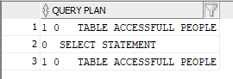
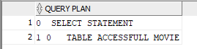

As we can see both of the queries ignored the hush cluster and did a full table scan. They did that because the optimizer prefers the least costing path in order to make the command. In our case this happened because we did a range scan and in range scan the hush cluster is not that efficient.

C)

q1 q2
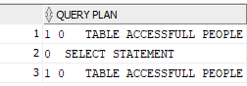

It completely ignored the index and due to reading the lectures and searching online this actually can happen quite often and only if it is a must the full table scan will be replaced by the index. Because it made a RANGE scan, it means that the Cost-based Optimizer doesn't think the index is very useful. So that's why it makes a full scan instead.

E)

q1 q2
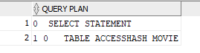
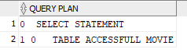

As we can see it shows a full table access in the first query
but in the second one it uses Hash not full so it uses the
index of B+-Tree because it is performing a range scan and
for range scan B+-Tree is very beneficial.

TASK 2

A,B)
q1 q2
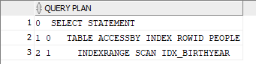
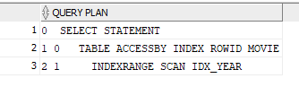

We can see that now q1 uses the index(despite it is not optimal, so it is slower than using a full table access).The reason why this is happening is because RULE is an old way that the optimizer used to create an execution plan.The reason is that it has generic rules about the tables and not specific statistics for each one so with RULE you cannot surely get the best result as we can see from q1.

The same thing happens as well in q2 for the reasons I mentioned above.

q1 q2
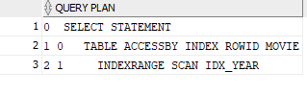
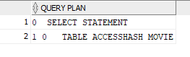

It is no surprise that in E, both queries use their indexes in the execution plan. For q2 the decision using RULE is correct because the index in this case will actually speed up the process. The problem lies in the decision of q1 not to do a full table scan. That's why RULE is considered and old tactic and in the oracles official website it recommends users to create newly programs only with cost based optimizer modes.

C)

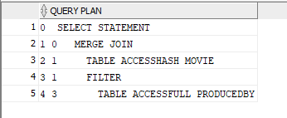

As it can be seen it used the HASH CLUSTER because hash cluster is very useful when we have (SELECT … WHERE cluster_key = …;) .The FILTER is used because we are getting more data than we need so to all rows a filter will be applied and only if that passed will be sent along.

Unique unclustered B+-Trees are not optimal for multi point queries and multi range scan queries. We have one multi point query so that's why the optimizer chose the hash cluster instead of the unique unclustered B+- Tree.

TASK 3

A)
OPTIMIZATION_MODE RULE

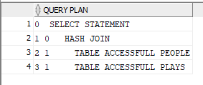
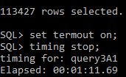

OPTIMIZATION_MODE FIRST_ROWS

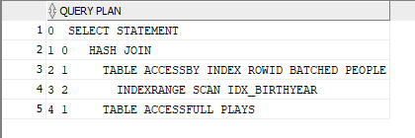
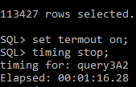

OPTIMIZATION_MODE ALL_ROWS

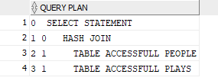
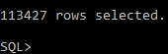

RULE:
As we can see the rule mode was faster in this query because it only used the hash join and not an index as was hinted in the query.
FIRST_ROWS:
Because of the hint that was used (forced) it made the query slower due do the fact that hashing in this case is not optimal. But why is it not optimal? Because you cannot afford to preallocate the space that the hash cluster will eventually need.
ALL_ROWS:

B)
OPTIMIZATION_MODE RULE

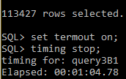
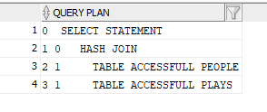

OPTIMIZATION_MODE FIRST_ROWS

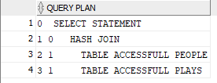
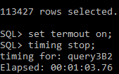

OPTIMIZATION_MODE ALL_ROWS

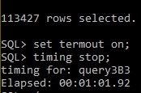
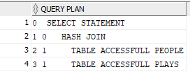

RULE:
As we can see the rule mode was faster comparing with the previous (A1) but this time it was the slower approach on this query considering the execution times of the above queries(FIRST_ROWS, ALL_ROWS).
FIRST_ROWS:
Now that the index was dropped we can see that the cost based optimizer modes were far superior on the execution time of the query. Range scan queries were not advantageous if we have used the index that was dropped and we can easily clarify this by comparing the execution times of (A),(B).
ALL_ROWS:

This mode is the fastest in this scenario because this is the preferred way if we process lots of single transactions in a query and because every insertion is a transaction we have the fasted results with ALL_ROWS.

C)

OPTIMIZATION_MODE RULE

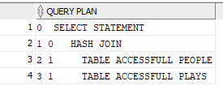
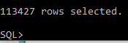

OPTIMIZATION_MODE FIRST_ROWS

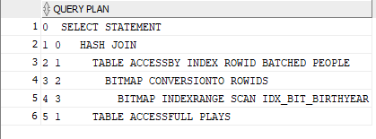
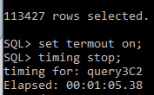

OPTIMIZATION_MODE ALL_ROWS

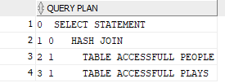
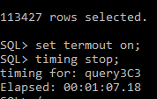

RULE:

FIRST_ROWS:
Due to the fact the a bitmap was used the FIRST_ROWS optimizer mode is faster that the reset modes in this particular scenario. Bitmap is very beneficial for range scans(when we have keywords like AND, OR, XOR ).FIRST_ROWS will try to give the first rows as fast as possible even if the overall query takes longer to execute. But because of that it uses indexes more often.
ALL_ROWS:
It is slightly slower than FIRST_ROWS because it used full table scan(peculiarities of those 2 optimizer modes) instead of the bitmap.

D)

RULE:
If we use the RULE method in contraction with indexes we slow down the RULE execution because it follows general rules and not specific for each query. The fastest RULE is if we have no indexes and then we use it but even with that it is very outdated and we have better alternatives.
FIRST_ROWS:
Using the cost based optimizer modes we are getting more consistent results. Between the index and the bitmap it is more advantageous the index due to the extra time(We can see that in the (C explain plan) bitmap we need extra time to convert rows-id that's why it is faster the index but the difference in negligible.
ALL_ROWS:
The same as above are also the reason for the faster execution time in B.

E)

OPTIMIZATION_MODE RULE

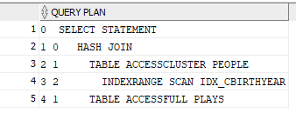
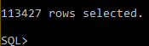

OPTIMIZATION_MODE FIRST_ROWS

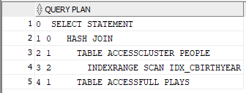
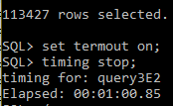

OPTIMIZATION_MODE ALL_ROWS

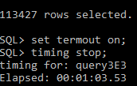
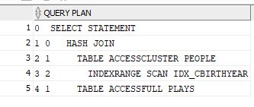

RULE:

FIRST_ROWS,ALL_ROWS:
Both of these optimizer modes are using the cluster because it is very beneficial for range queries and it speeds up the query execution. We can verify this by comparing the results with the previous question and we can see ALL_ROWS now used the cluster instead of a full access in PEOPLE. FIRST_ROWS was slightly faster due to the fact that tries to find the first rows as fast as possible.

THANKS A LOT

